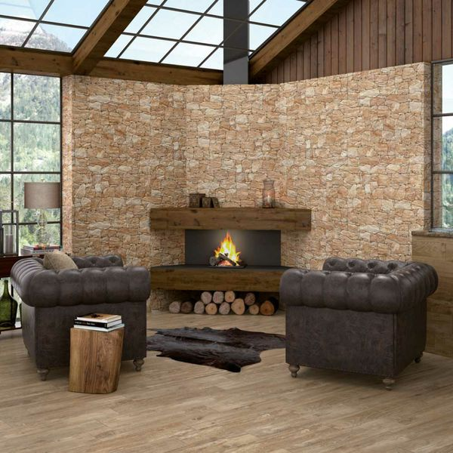

**Stacked Sand Stone Effect Tiles:**

## **Product Description**

Reinvent the wall spaces through your home with these Stacked Sand Stone Effect Tiles. They allow you to create the illusion of a stacked dry wall; the kind you might find in a country farmhouse. They're perfect for creating a feature wall in a bathroom, kitchen, living area, or even outside in the garden. Made from porcelain, they have a textured surface and a matt finish. For a grout that matches the faux groutlines contained within these tiles, try our [Ultracolour Plus 114 Antracita Tile Grout](https://www.wallsandfloors.co.uk/catrangetiles/tile-grouts/mapei-grouts/mapei-ultracolour-plus-114-grout/16724/). They're suitable for use on both internal and external wall spaces.

## **Product Info**

* Product ID: 15313
* Tiles Per SQM: 4.6200046200046
* Sale by: Per SQM
* Size: 650x333x10mm
* Weight: 4.20 KG
* Material Type: Porcelain
* Finish: Matt
* Colour: Beige/Ivory
* Suitability: Walls
* Grade: 4
* Rectified Edge: No
* Underfloor Heating: No
* Thickness (mm): 10